LAB 1

TITLE: Process Creation using fork() System Call in C.

OBJECTIVE: To understand and implement process creation using the fork() system call, and to demonstrate how a parent and child process operate independently.

THEORY:
The fork() system call is used to create a new process by duplicating the calling process. The newly created process is called the child process, and the original is called the parent process.
fork() Characteristics:
- It returns:
  - 0 to the child process
  - A positive value (PID of child) to the parent process
  - -1 if the process creation fails
- After calling fork(), both parent and child execute the same code but can behave differently using if (pid == 0) and else condition.
- The wait() function makes the parent wait until the child process terminates.

🔸 Key Functions Used:
- fork() – to create a new process
- getpid() – to get current process ID
- getppid() – to get parent process ID
- wait() – to make parent wait for child
- sleep() – to simulate delay

Algorithm:
- Start
- Declare pid variable of type pid_t
- Call fork() to create a new process
- Check if fork() returned:
  - < 0: Print error and exit
  - 0: It is the child process. Print child details and simulate work with sleep()
  - > 0: It is the parent process. Print parent details and wait for the child to finish
- Exit both processes

PROGRAMS
#include <stdio.h>
#include <unistd.h> // Required for fork() and sleep()
#include <sys/types.h> // Required for pid_t
#include <sys/wait.h> // Required for wait()

int main() {
pid_t pid; // Process ID variable

// Create a new process
pid = fork();

// Check for fork error
if (pid < 0) {
fprintf(stderr, "Fork failed\n");
return 1;
}

// Child process
if (pid == 0) {
printf("Child process:\n");
printf(" PID: %d\n", getpid());
printf(" Parent PID: %d\n", getppid());
printf(" Child is sleeping for 2 seconds...\n");
sleep(2); // Simulate some work
printf(" Child exiting\n");
}
// Parent process
else {
printf("Parent process:\n");
printf(" PID: %d\n", getpid());
printf(" Child PID: %d\n", pid);
printf(" Parent waiting for child...\n");
wait(NULL); // Wait for child to finish
printf(" Parent exiting\n");
}

return 0;
}

Output:

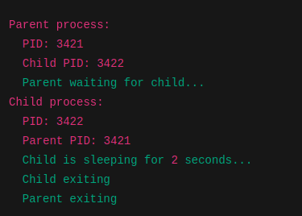

RESULTS:
The program successfully demonstrates process creation using the fork() system call. A parent process creates a child process, waits for it to finish, and then exits.

CONCLUSION:
This lab provided hands-on experience with process management in OS, particularly using the fork() system call. It showed how processes are created and how a parent can manage child execution using wait().

